Slavery in the United States
- In the late eighteenth (18th) Century slavery seemed to be a dying institution in America; but during the early 100’s economic changes led to its strong revival in the states in the south.

- During the years following the revolution the climate of opinion was growing against slavery, furthermore the use of slaves did not seem to be that necessary or profitable.

- Around the turn of the century a great cotton boom came to the south, and with a new demand for slaves to work in the fields.

- The entire southern society came to rest upon the institution of slavery.

- Up until the time of the civil war political and social leadership in the south lay in the hands of a few thousand families: an aristocracy of large plantation owners.

- But even among the three-fourths of the white population who did not own slaves, slavery was accepted and defended.

- The conditions under which the slaves lived varied greatly from one situation to another.

- Many slaves, particularly where they lived and worked close to their owners, enjoyed kind treatment and relatively easy conditions; on large plantations , however, there was a tendency for field hands to be treated with greater harshness.

- Some slaves rebelled against their bondage; but some seemed (outwardly at least) to be contented with their condition.

- In the south considerable intellectual effort was devoted to defending the institution of slavery as reasonable and good.

- During the 1830’s a change in the social climate in the south took place, leading to ever fiercer commitment to the institution of slavery. Instead of being defended as a “necessary evil”, attempts were made to show that it was a “positive good”.

- Both scientific and religious arguments were used to support slavery.

- The life of black slaves in America was pictured as happy and compared with the desperate condition of the industrial workers in northern cities and England.

- The southern white culture which was made possible by slavery was pictured as noble and ideal.

- Opposition to slavery grew increasingly strong in the north.

- Many American leaders favoured policies of progressive emancipation and re-colonisation of freed slaves in Africa.

- A growing radical abolitionist movement was led by William Garrison.

- Even among Northerners that opposed slavery, many were not ready to view blacks as fellow citizens with equal rights and abilities.

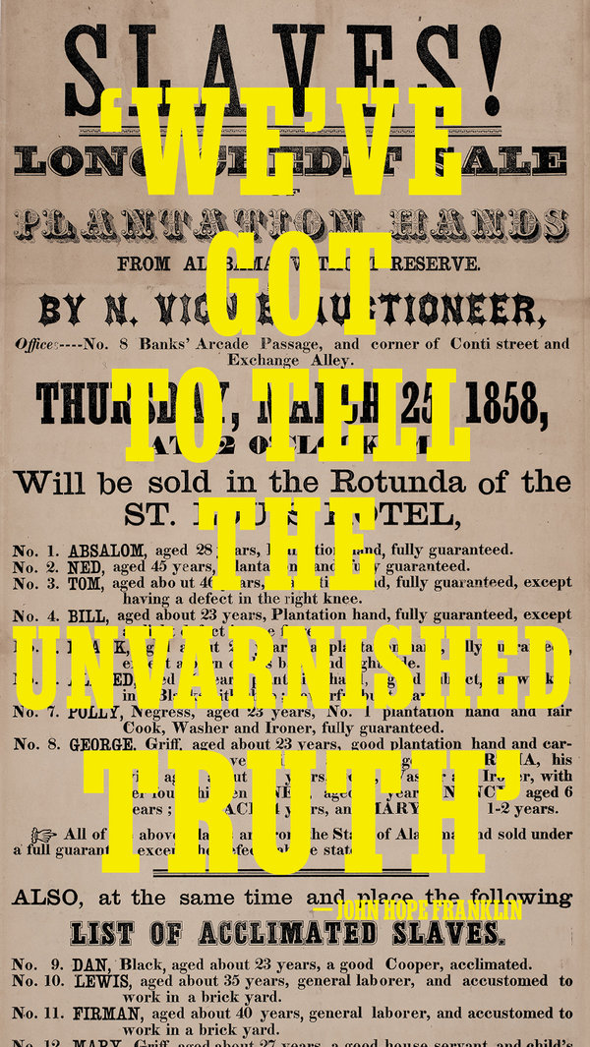
ARTWORK BY DEB BISHOP
Four hundred years after enslaved Africans were first brought to Virginia, most Americans still don’t know the full story of slavery.
Curated by Mary Elliott
All text by Mary Elliott and Jazmine HughesAug. 19, 2019
Sometime in 1619, a Portuguese slave ship, the São João Bautista, traveled across the Atlantic Ocean with a hull filled with human cargo: captive Africans from Angola, in southwestern Africa. The men, women and children, most likely from the kingdoms of Ndongo and Kongo, endured the horrific journey, bound for a life of enslavement in Mexico. Almost half the captives had died by the time the ship was seized by two English pirate ships; the remaining Africans were taken to Point Comfort, a port near Jamestown, the capital of the English colony of Virginia, which the Virginia Company of London had established 12 years earlier. The colonist John Rolfe wrote to Sir Edwin Sandys, of the Virginia Company, that in August 1619, a “Dutch man of war” arrived in the colony and “brought not anything but 20 and odd Negroes, which the governor and cape merchant bought for victuals.” The Africans were most likely put to work in the tobacco fields that had recently been established in the area.
[Read our essay on why American schools can’t teach slavery right.]
Forced labor was not uncommon — Africans and Europeans had been trading goods and people across the Mediterranean for centuries — but enslavement had not been based on race. The trans-Atlantic slave trade, which began as early as the 15th century, introduced a system of slavery that was commercialized, racialized and inherited. Enslaved people were seen not as people at all but as commodities to be bought, sold and exploited. Though people of African descent — free and enslaved — were present in North America as early as the 1500s, the sale of the “20 and odd” African people set the course for what would become slavery in the United States.
The broadside pictured above advertised a slave auction at the St. Louis Hotel in New Orleans on March 25, 1858. Eighteen people were for sale, including a family of six whose youngest child was 1. The artifact is part of the collection of The Smithsonian's National Museum of African American History and Culture. Its curator of American Slavery, Mary Elliott, co-wrote the history of slavery below — told primarily through objects in the museum's collection.
o. 1 /
slavery, power and the human cost
1455 - 1775
In the 15th century, the Roman Catholic Church divided the world in half, granting Portugal a monopoly on trade in West Africa and Spain the right to colonize the New World in its quest for land and gold. Pope Nicholas V buoyed Portuguese efforts and issued the Romanus Pontifex of 1455, which affirmed Portugal’s exclusive rights to territories it claimed along the West African coast and the trade from those areas. It granted the right to invade, plunder and “reduce their persons to perpetual slavery.” Queen Isabella invested in Christopher Columbus’s exploration to increase her wealth and ultimately rejected the enslavement of Native Americans, claiming that they were Spanish subjects. Spain established an asiento, or contract, that authorized the direct shipment of captive Africans for trade as human commodities in the Spanish colonies in the Americas. Eventually other European nation-states — the Netherlands, France, Denmark and England — seeking similar economic and geopolitical power joined in the trade, exchanging goods and people with leaders along the West African coast, who ran self-sustaining societies known for their mineral-rich land and wealth in gold and other trade goods. They competed to secure the asiento and colonize the New World. With these efforts, a new form of slavery came into being. It was endorsed by the European nation-states and based on race, and it resulted in the largest forced migration in the world: Some 12.5 million men, women and children of African descent were forced into the trans-Atlantic slave trade. The sale of their bodies and the product of their labor brought the Atlantic world into being, including colonial North America. In the colonies, status began to be defined by race and class, and whether by custom, case law or statute, freedom was limited to maintain the enterprise of slavery and ensure power.
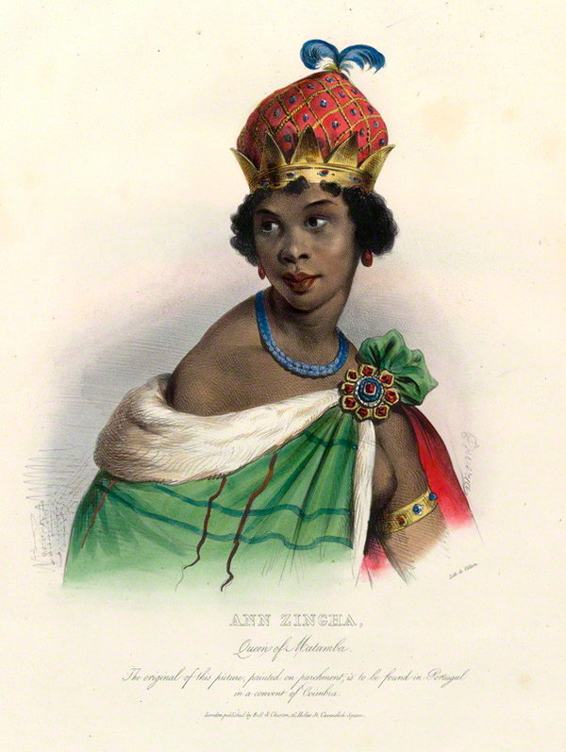
National Portrait Gallery, London
Queen Njinga
Hand-colored lithograph by Achille Devéria, 1830s.
In 1624, after her brother’s death, Ana Njinga gained control of the kingdom of Ndongo, in present-day Angola. At the time, the Portuguese were trying to colonize Ndongo and nearby territory in part to acquire more people for its slave trade, and after two years as ruler, Njinga was forced to flee in the face of Portuguese attack. Eventually, however, she conquered a nearby kingdom called Matamba. Njinga continued to fight fiercely against Portuguese forces in the region for many years, and she later provided shelter for runaway slaves. By the time of Njinga’s death in 1663, she had made peace with Portugal, and Matamba traded with it on equal economic footing. In 2002, a statue of Njinga was unveiled in Luanda, the capital of Angola, where she is held up as an emblem of resistance and courage.
Erica Deeman for The New York Times. Objects from the Smithsonian's National Museum of African American History and Culture. Ballast block on loan from Iziko Museums of South Africa.
Means of Control
Right: An iron ballast block used to counterbalance the weight of enslaved persons aboard the São José Paquete Africa slave ship, which left Mozambique in 1794 and sank near what is now Cape Town, South Africa. Left: A child’s iron shackles, before 1860.
“The iron entered into our souls,” lamented a formerly enslaved man named Caesar, as he remembered the shackles he had to wear during his forced passage from his home in Africa to the New World. Used as restraints around the arms and legs, the coarse metal cut into captive Africans’ skin for the many months they spent at sea. Children made up about 26 percent of the captives. Because governments determined by the ton how many people could be fitted onto a slave ship, enslavers considered children especially advantageous: They could fill the boat’s small spaces, allowing more human capital in the cargo hold. Africans were crammed into ships with no knowledge of where they were going or if they would be released. This forced migration is known as the Middle Passage. As Olaudah Equiano, the formerly enslaved author, remembered, “I was soon put down under the decks, and there I received such a salutation in my nostrils as I had never experienced in my life: so that, with the loathsomeness of the stench, and crying together, I became so sick and low that I was not able to eat, nor had I the least desire to taste anything. I now wished for the last friend, death, to relieve me.” Overheating, thirst, starvation and violence were common aboard slave ships, and roughly 15 percent of each ship’s enslaved population died before they ever reached land. Suicide attempts were so common that many captains placed netting around their ships to prevent loss of human cargo and therefore profit; working-class white crew members, too, committed suicide or ran away at port to escape the brutality. Enslaved people did not meekly accept their fate. Approximately one out of 10 slave ships experienced resistance, ranging from individual defiance (like refusing to eat or jumping overboard) to full-blown mutiny.
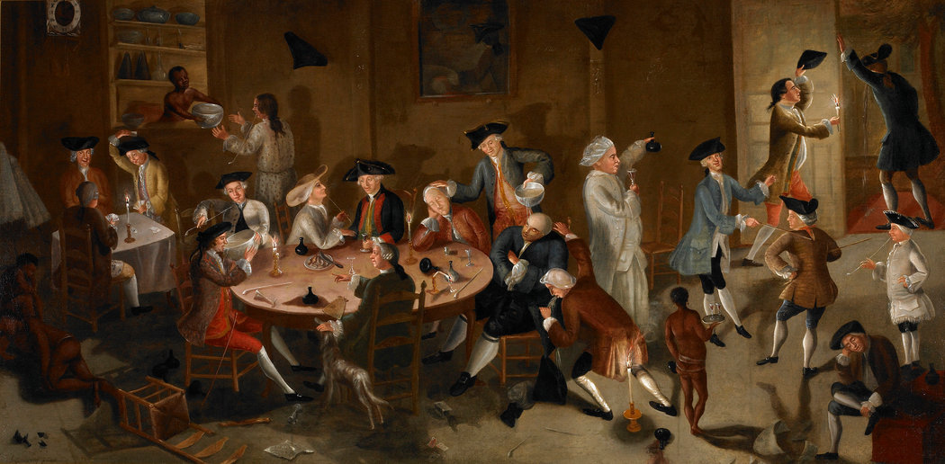
Saint Louis Art Museum
Cultivating Wealth and Power
“Sea Captains Carousing in Surinam,” painted by John Greenwood, circa 1752-58.
The slave trade provided political power, social standing and wealth for the church, European nation-states, New World colonies and individuals. This portrait by John Greenwood connects slavery and privilege through the image of a group of Rhode Island sea captains and merchants drinking at a tavern in the Dutch colony of Surinam, a hub of trade. These men made money by trading the commodities produced by slavery globally — among the North American colonies, the Caribbean and South America — allowing them to secure political positions and determine the fate of the nation. The men depicted here include the future governors Nicholas Cooke and Joseph Wanton; Esek Hopkins, a future commander in chief of the Continental Navy; and Stephen Hopkins, who would eventually become one of the signers of the Declaration of Independence.
ll children borne in this country shall be held bond or free only according to the condition of the mother.’
— Virginia law enacted in 1662
Race Encoded Into Law
The use of enslaved laborers was affirmed — and its continual growth was promoted — through the creation of a Virginia law in 1662 that decreed that the status of the child followed the status of the mother, which meant that enslaved women gave birth to generations of children of African descent who were now seen as commodities. This natural increase allowed the colonies — and then the United States — to become a slave nation. The law also secured wealth for European colonists and generations of their descendants, even as free black people could be legally prohibited from bequeathing their wealth to their children. At the same time, racial and class hierarchies were being coded into law: In the 1640s, John Punch, a black servant, escaped bondage with two white indentured servants. Once caught, his companions received additional years of servitude, while Punch was determined enslaved for life. In the wake of Bacon’s Rebellion, in which free and enslaved black people aligned themselves with poor white people and yeoman white farmers against the government, more stringent laws were enacted that defined status based on race and class. Black people in America were being enslaved for life, while the protections of whiteness were formalized.
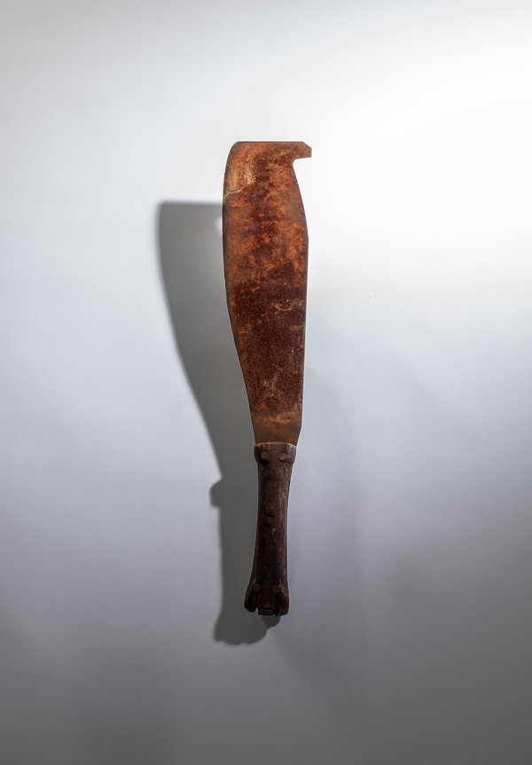
Erica Deeman for The New York Times. Object from the Smithsonian's National Museum of African American History and Culture.
A Deadly Commodity
Sugar cane cutter, metal and wood, 19th century.
Before cotton dominated American agriculture, sugar drove the slave trade throughout the Caribbean and Spanish Americas. Sugar cane was a brutal crop that required constant work six days a week, and it maimed, burned and killed those involved in its cultivation. The life span of an enslaved person on a sugar plantation could be as little as seven years. Unfazed, plantation owners worked their enslaved laborers to death and prepared for this high “turnover” by ensuring that new enslaved people arrived on a regular basis to replace the dying. The British poet William Cowper captured this ethos when he wrote, “I pity them greatly, but I must be mum, for how could we do without sugar or rum?” The sweetening of coffee and tea took precedence over human life and set the tone for slavery in the Americas.
Continual Resistance
Enslaved Africans had known freedom before they arrived in America, and they fought to regain it from the moment they were taken from their homes, rebelling on plantation sites and in urban centers. In September 1739, a group of enslaved Africans in the South Carolina colony, led by an enslaved man called Jemmy, gathered outside Charleston, where they killed two storekeepers and seized weapons and ammunition. “Calling out Liberty,” according to Gen. James Oglethorpe, the rebels “marched on with Colours displayed, and two Drums beating” along the Stono River, entreating other members of the enslaved community to join them. Their goal was Spanish Florida, where they were promised freedom if they fought as the first line of defense against British attack. This effort, called the Stono Rebellion, was the largest slave uprising in the mainland British colonies. Between 60 and 100 black people participated in the rebellion; about 40 black people and 20 white people were killed, and other freedom fighters were captured and questioned. White lawmakers in South Carolina, afraid of additional rebellions, put a 10-year moratorium on the importation of enslaved Africans and passed the Negro Act of 1740, which criminalized assembly, education and moving abroad among the enslaved. The Stono Rebellion was only one of many rebellions that occurred over the 246 years of slavery in the United States.

Erica Deeman for The New York Times. Object from the Smithsonian's National Museum of African American History and Culture.
Memory and Place-Making
Low Country basket, 19th century.
Enslaved black people came from regions and ethnic groups throughout Africa. Though they came empty-handed, they carried with them memories of loved ones and communities, moral values, intellectual insight, artistic talents and cultural practices, religious beliefs and skills. In their new environment, they relied on these memories to create new practices infused with old ones. In the Low Country region of the Carolinas and Georgia, planters specifically requested skilled enslaved people from a region stretching from Senegal to Liberia, who were familiar with the conditions ideal for growing rice. Charleston quickly became the busiest port for people shipped from West Africa. The coiled or woven baskets used to separate rice grains from husks during harvest were a form of artistry and technology brought from Africa to the colonies. Although the baskets were utilitarian, they also served as a source of artistic pride and a way to stay connected to the culture and memory of the homeland.
o. 2 /
he imits of reedom
1776 - 1808
We hold these truths to be self-evident, that all men are created equal, that they are endowed by their Creator with certain unalienable Rights, that among these are Life, Liberty and the pursuit of Happiness.” So begins the Declaration of Independence, the document that eventually led to the creation of the United States. But the words point to the paradox the nation was built on: Even as the colonists fought for freedom from the British, they maintained slavery and avoided the issue in the Constitution. Enslaved people, however, seized any opportunity to secure their freedom. Some fought for it through military service in the Revolutionary War, whether serving for the British or the patriots. Others benefited from gradual emancipation enacted in states like Pennsylvania, New York and New Jersey. In New York, for example, children born after July 4, 1799, were legally free when they turned 25, if they were women, or 28, if they were men — the law was meant to compensate slaveholders by keeping people enslaved during some of their most productive years.
[How was slavery taught in your school? We want to hear your story.]
Yet the demand for a growing enslaved population to cultivate cotton in the Deep South was unyielding. In 1808, Congress implemented the Act Prohibiting Importation of Slaves, which terminated the country’s legal involvement in the international slave trade but put new emphasis on the domestic slave trade, which relied on buying and selling enslaved black people already in the country, often separating them from their loved ones. (In addition, the international trade continued illegally.) The ensuing forced migration of over a million African-Americans to the South guaranteed political power to the slaveholding class: The Three-Fifths Clause that the planter elite had secured in the Constitution held that three-fifths of the enslaved population was counted in determining a state’s population and thus its congressional representation. The economic and political power grab reinforced the brutal system of slavery.

Illustration by Jamaal Barber
A Powerful Letter
Benjamin Banneker and Thomas Jefferson.
After the Revolutionary War, Thomas Jefferson and other politicians — both slaveholding and not — wrote the documents that defined the new nation. In the initial draft of the Declaration of Independence, Jefferson condemned King George III of Britain for engaging in the slave trade and ignoring pleas to end it, and for calling upon the enslaved to rise up and fight on behalf of the British against the colonists. This language was excised from the final document, however, and all references to slavery were removed, in stunning contrast to the document’s opening statement on the equality of men. Jefferson was a lifelong enslaver. He inherited enslaved black people; he fathered enslaved black children; and he relied on enslaved black people for his livelihood and comfort. He openly speculated that black people were inferior to white people and continually advocated for their removal from the country. In 1791, Benjamin Banneker, a free black mathematician, scientist, astronomer and surveyor, argued against this mind-set when he wrote to Jefferson, then secretary of state, urging him to correct his “narrow prejudices” and to “eradicate that train of absurd and false ideas and opinions, which so generally prevails with respect to us.” Banneker also condemned Jefferson’s slaveholding in his letter and included a manuscript of his almanac, which would be printed the following year. Jefferson was unconvinced of the intelligence of African-Americans, and in his swift reply only noted that he welcomed “such proofs as you exhibit” of black people with “talents equal to those of the other colors of men.”

From the Massachusetts Historical Society
She Sued for Her Freedom
A miniature portrait of Mum Bett by Susan Anne Livingston Ridley Sedgwick, 1811.
In the wake of the Revolutionary War, African-Americans took their cause to statehouses and courthouses, where they vigorously fought for their freedom and the abolition of slavery. Elizabeth Freeman, better known as Mum Bett, an enslaved woman in Massachusetts whose husband died fighting during the Revolutionary War, was one such visionary. The new Massachusetts Constitution of 1780 stated that “All men are born free and equal, and have certain natural, essential and unalienable rights; among which may be reckoned the right of enjoying and defending their lives and liberties.” Arguing that slavery violated this sentiment, Bett sued for her freedom and won. After the ruling, Bett changed her name to Elizabeth Freeman to signify her new status. Her precedent-setting case helped to effectively bring an end to slavery in Massachusetts.
‘f one minute’s freedom had been offered to me, and had been told must die at the end of that minute, would have taken it.’
— Mum Bett

From the Smithsonian’s Museum of African American History and Culture
God Wouldn’t Want Segregated Sanctuaries
1916 poster for the Mother Bethel A.M.E. Church in Philadelphia, with its founder, Richard Allen, at center.
Black people, both free and enslaved, relied on their faith to hold onto their humanity under the most inhumane circumstances. In 1787, the Rev. Richard Allen and other black congregants walked out of services at St. George’s Methodist Episcopal Church in Philadelphia to protest its segregated congregations. Allen, an abolitionist who was born enslaved, had moved to Philadelphia after purchasing his freedom. There he joined St. George’s, where he initially preached to integrated congregations. It quickly became clear that integration went only so far: He was directed to preach a separate service designated for black parishioners. Dismayed that black people were still treated as inferiors in what was meant to be a holy space, Allen founded the African Methodist Episcopal denomination and started the Mother Bethel A.M.E. Church. For communities of free people of color, churches like Allen’s were places not only of sanctuary but also of education, organizing and civic engagement, providing resources to navigate a racist society in a slave nation. Allen and his successors connected the community, pursued social justice and helped guide black congregants as they transitioned to freedom. The African Methodist Episcopal Church grew rapidly; today at least 7,000 A.M.E. congregations exist around the world, including Allen’s original church.

From the Library of Congress
The Destructive Impact of the Cotton Gin
Wood-engraving illustration of a cotton gin, Harper’s Weekly, 1859.
The national dialogue surrounding slavery and freedom continued as the demand for enslaved laborers increased. In 1794, Eli Whitney patented the cotton gin, which made it possible to clean cotton faster and get products to the market more quickly. Cotton was king, as the saying went, and the country became a global economic force. But the land for cultivating it was eventually exhausted, and the nation would have to expand to keep up with consumer demand. In 1803, Thomas Jefferson struck a deal with Napoleon Bonaparte, the Louisiana Purchase: In exchange for $15 million, the United States gained almost 830,000 square miles of land, doubling the size of the country and expanding America’s empire of slavery and cotton. Soon after this deal, the United States abolished the international slave trade, creating a labor shortage. Under these circumstances, the domestic slave trade increased as an estimated one million enslaved people were sent to the Deep South to work in cotton, sugar and rice fields.
Describing the Depravity of Slavery
“Benevolent men have voluntarily stepped forward to obviate the consequences of this injustice and barbarity,” proclaimed the Rev. Peter Williams Jr. in a historic speech about the end of the nation’s involvement in the trans-Atlantic slave trade. “They have striven assiduously to restore our natural rights; to guaranty them from fresh innovations; to furnish us with necessary information; and to stop the source from whence our evils have flowed.” A free black man who founded St. Philip’s African Church in Manhattan, Williams spoke in front of a white and black audience on Jan. 1, 1808 — the day the United States ban on the international slave trade went into effect. The law, of course, did not end slavery, and it was often violated. Williams forced the audience to confront slavery’s ugliness as he continued, “Its baneful footsteps are marked with blood; its infectious breath spreads war and desolation; and its train is composed of the complicated miseries of cruel and unceasing bondage.” His oration further defined a black view of freedom that had been building since the foundation of the country, as when the formerly enslaved poet Phillis Wheatley noted in 1774,“for in every human Breast, God has implanted a Principle, which we call love of Freedom; it is impatient of Oppression, and pants for Deliverance.”
o. 3 /
lave ation ights for reedom
1809 - 1865
As demand for cotton grew and the nation expanded, slavery became more systemic, codified and regulated — as did the lives of all enslaved people. The sale of enslaved people and the products of their labor secured the nation’s position as a global economic and political powerhouse, but they faced increasingly inhumane conditions. They were hired out to increase their worth, sold to pay off debts and bequeathed to the next generation. Slavery affected everyone, from textile workers, bankers and ship builders in the North; to the elite planter class, working-class slave catchers and slave dealers in the South; to the yeoman farmers and poor white people who could not compete against free labor. Additionally, in the 1830s, President Andrew Jackson implemented his plan for Indian removal, ripping another group of people from their ancestral lands in the name of wealth. As slavery spread across the country, opposition — both moral and economic — gained momentum. Interracial abolition efforts grew in force as enslaved people, free black people and some white citizens fought for the end of slavery and a more inclusive definition of freedom. The nation was in transition, and it came to a head after Abraham Lincoln was elected president; a month later, in December 1860, South Carolina seceded from the Union, citing “an increasing hostility on the part of the non- slaveholding states to the institution of slavery” as a cause. Five years later, the Civil War had ended, and 246 years after the “20 and odd Negroes” were sold in Virginia, the 13th Amendment ensured that the country would never again be defined as a slave nation.

Erica Deeman for The New York Times. Object from the Smithsonian's National Museum of African American History and Culture.
A Woman Bequeathed
Daguerreotype of Rhoda Phillips, circa 1850.
Rhoda Phillips’s name was officially written down for the first time in 1832, in the record of her sale. She was purchased when she was around 1 year old, along with her mother, Milley, and her sister Martha, for $550. The enslaver Thomas Gleaves eventually acquired Rhoda. He bequeathed her to his family in his will, where she is listed as valued at $200. She remained enslaved by them until the Emancipation Proclamation in 1863. Afterward, Rhoda is believed to have married a man and had eight children with him. When she died, the Gleaves family ran an obituary in The Nashville Banner that showed the family still could not see the inhumanity of slavery. “Aunt Rhody,” the obituary said, “was raised by Mr. Gleaves and has lived with the family all her life. She was one of the old-time darkies that are responsible for the making of so many of their young masters.” In this daguerreotype of Rhoda, she is about 19, and in contrast to the practice at the time, Rhoda appears alone in the frame. Typically, enslaved people were shown holding white children or in the background of a family photo, the emphasis placed on their servitude. Rhoda’s story highlights one of the perversities of slavery: To the Gleaves, Rhoda was a family member even as they owned her.
By Black People, for Black People
On March 16, 1827, the same year that slavery was abolished in New York, Peter Williams Jr. co-founded Freedom’s Journal, the first newspaper owned and operated by African-Americans. A weekly New York paper, it was edited by John Russwurm and Samuel Cornish, who wrote in their first editorial, “We wish to plead our own cause. Too long have others spoken for us. Too long has the publick been deceived by misrepresentations.” Russwurm and Cornish wanted the paper to strengthen relations among newly freed black people living in the North and counter racist and hostile representations of African-Americans in other papers. At its peak, the paper circulated in 11 states and internationally. Although it folded in 1829, Freedom’s Journal served as inspiration for other black newspapers, and by the start of the Civil War, there were at least two dozen black-owned papers in the country. The renowned abolitionist and scholar Frederick Douglass used his newspapers to call for and to secure social justice.
Generations of Enslavement
On March 7, 1854, Sally and her three daughters, Sylvia, Charlotte and Elizabeth, were sold for $1,200. Sally was able to remain with her children, at least for a short time, but most enslaved women had to endure their children being forcibly taken from them. Their ability to bear children — their “increase” — was one of the reasons they were so highly valued. Laws throughout the country ensured that a child born to an enslaved woman was also the property of the enslaver to do with as he saw fit, whether to make the child work or to sell the child for profit. Many enslaved women were also regularly raped, and there were no laws to protect them; white men could do what they wanted without reproach, including selling the offspring — their offspring — that resulted from these assaults. Many white women also served as enslavers; there was no alliance of sisterhood among slave mistresses and the black mothers and daughters they claimed as property.
‘rethren, arise, arise! trike for your lives and liberties. ow is the day and the hour. ... et your motto be resistance!’
—Henry Highland Garnet, 1843
Liberation Theology
In 1831, Nat Turner, along with about 70 enslaved and free black people, led a revolt in Southampton County, Va., that shook the nation. Turner, a preacher who had frequent, powerful visions, planned his uprising for months, putting it into effect following a solar eclipse, which he interpreted as a sign from God. He and his recruits freed enslaved people and killed white men, women and children, sparing only a number of poor white people. They killed nearly 60 people over two days, before being overtaken by the state militia. Turner went into hiding, but he was found and hanged a few months later. It was one of the deadliest revolts during slavery, a powerful act of resistance that left enslavers scared — both for their lives and for the loss of their “property.” The Virginia resident Eleanor Weaver reflected on the events, stating in a letter to family members: “We hope our government will take some steps to put down Negro preaching. It is those large assemblies of Negroes causes the mischief.” More stringent laws went into effect that controlled the lives of black people, free or enslaved, limiting their ability to read, write or move about.
The Slave Patrols
In 1846, Col. Henry W. Adams, of the 168th Regiment, Virginia Militia, started a slave patrol in Pittsylvania County, Va., that would “visit all Negro quarters and other places suspected of entertaining unlawful assemblies of slaves ... as aforesaid, unlawfully assembled, orany others strolling from one plantation to another, without a pass from his or her master or mistress or overseer, and take them before the next justice of the peace, who if he shall see cause, is hereby required to order every such slave ... aforesaid to receive any number of lashes, not exceeding 20 on his or her back.” Slave patrols throughout the nation were created by white people who were fearful of rebellion and were seeking to protect their human property. While overseers were employed on plantation sites as a means of control, slave patrols — which patrolled plantations, streets, woods and public areas — were thought to serve the larger community. While slave patrols tried to enforce laws that limited the movement of the enslaved community, black people still found ways around them.
Growing National Tension
In 1850, Congress passed a new Fugitive Slave Act, which required that all citizens aid in the capturing of fugitive enslaved black people. Lack of compliance was considered breaking the law. The previous act, from 1793, enabled enslavers to pursue runaway enslaved persons, but it was difficult to enforce. The 1850 act — which created a legal obligation for Americans, regardless of their moral views on slavery, to support and enforce the institution — divided the nation and undergirded the path to the Civil War. Black people could not testify on their own behalf, so if a white person incorrectly challenged the status of a free black person, the person was unable to act in his or her own defense and could be enslaved. In 1857, Dred Scott, who was enslaved, went to court to claim his freedom after his enslaver transported him into a free state and territory. The Supreme Court determined his fate when Chief Justice Roger B. Taney stated that no black person, free or enslaved, could petition the court because they were not “citizens within the meaning of the Constitution.” By statute and interpretation of the law, black people in America were dehumanized and commodifiedin order to maintain the economic and political power supported by slavery.
Erica Deeman for The New York Times. Object from the Smithsonian's National Museum of African American History and Culture.
Enlisting in a Moral Fight
Carte de visite silver gelatin portrait of Sgt. Jacob Johns.
It is unclear whether Jacob Johns was enslaved, recently freed or a free man when he enlisted in the Union Army as a sergeant in the 19th United States Colored Troops Infantry, Company B. His unit fought in 11 battles, and 293 of its men were killed or died of disease, including Johns. When the war began in 1861, enslaved African-Americans seized their opportunity for freedom by crossing the Union Army lines in droves. The Confederate states tried to reclaim their human “property” but were denied by the Union, which cleverly declared the formerly enslaved community as contraband of war — captured enemy property. President Abraham Lincoln initially would not let black men join the military, anxious about how the public would receive integrated efforts. But as casualties increased and manpower thinned, Congress passed the Second Confiscation and Militia Act in 1862, allowing Lincoln to “employ as many persons of African descent” as he needed, and thousands enlisted in the United States Colored Troops. Jacobs was one of nearly 180,000 black soldiers who served in the U.S.C.T. during the Civil War, a group that made up nearly one-tenth of all soldiers, fighting for the cause of freedom.

From the Smithsonian's Museum of African American History and Culture
Always on Your Person
Joseph Trammell’s freedom papers, 1852.
A free black man living in Loudoun County, Va., Joseph Trammell created this small metal tin to protect his certificate of freedom — proof that he was not enslaved. During slavery, freedom was tenuous for free black people: It could be challenged at any moment by any white person, and without proof of their status they could be placed into the slave trade. Trammell, under Virginia law, had to register his freedom every few years with the county court. But even for free black people, laws were still in place that limited their liberty — in many areas in the North and the South, they could not own firearms, testify in court or read and write — and in the free state of Ohio, at least two race riots occurred before 1865.
One Family’s Ledger
Slaveholding families kept meticulous records of their business transactions: buying, selling and trading people. A record of the Rouzee family’s taxable property includes five horses, 497 acres of land and 28 enslaved people. Records show the family enterprise including the purchase and sale of African-Americans, investment in provisions to maintain the enslaved community and efforts to capture an enslaved man who ran toward freedom. From one century to the next, the family profited from enslaved people, their wealth passing from generation to generation. As enslaved families were torn apart, white people — from the elite planter class to individuals invested in one enslaved person — were building capital, a legacy that continues today.
‘ shall never forget that memorable night, when in a distant city waited and watched at a public meeting, with 3,000 others not less anxious than myself, for the word of deliverance which we have heard read today. or shall ever forget the outburst of joy and thanksgiving that rent the air when the lightning brought to us the mancipation roclamation.’
— Frederick Douglass

From the Smithsonian's Museum of African American History and Culture
Freedom Begins
The Emancipation Proclamation in pamphlet form, published by John Murray Forbes, 1862.
On Sept. 22, 1862, Abraham Lincoln issued the preliminary Emancipation Proclamation, stating that if the Confederacy did not end its rebellion by Jan. 1, 1863, “all persons held as slaves” in the states that had seceded would be free. The Confederacy did not comply, and the proclamation went into effect. But the Emancipation Proclamation freed only those enslaved in the rebelling states, approximately 3.5 million people. It did not apply to half a million enslaved people in slaveholding states that weren’t part of the Confederacy — Kentucky, Maryland, Missouri, Delaware and what would become West Virginia — or to those people in parts of the Confederacy that were already under Northern control. They remained enslaved until Gen. Robert E. Lee surrendered at Appomattox in April 1865. The freedom promised by the proclamation — and the official legal end of slavery — did not occur until the ratification of the 13th Amendment on Dec. 6, 1865. Only then was the tyranny of slavery truly over. Nevertheless, the Emancipation Proclamation was deeply meaningful to the community of formerly enslaved African-Americans and their allies. Annual emancipation celebrations were established, including Juneteenth; across the country, African-American gathering spots were named Emancipation Park; and the words of the proclamation were read aloud as a reminder that African-Americans, enslaved and free, collectively fought for freedom for all and changed an entire nation.
‘he story of the frican-merican is not only the quintessential merican story but it’s really the story that continues to shape who we are today.’
— Lonnie G. Bunch III, secretary of the Smithsonian Institution
Mary Elliott is curator of American slavery at the Smithsonian’s National Museum of African American History and Culture, where she co-curated the ‘‘Slavery and Freedom’’ exhibition. Jazmine Hughes is a writer and editor at The New York Times Magazine.

