People’s Democratic Républic of Algeria Ministry of higher education and scientific
Research
University of Batna – 2
Faculty of nature and life sciences
Departement of the commoncore nature and life sciences
1st year LMD

Virology

Prepared by: Supervisior:
Faten Naceur Dr: Nora Chouha

Academic year: 2020/2021

Summary
Our report touches on many important points about virology such s (definition, history, various structures of viruses…….). Virology is an independent discipline, is not necessarily in the public eye, but is increasingly important spatially recently with the spread of new viruses as covid-19.

A contents :
Summary …………………02
- Introduction …………………05
- Definition of virology …………………06
- History of virology…………………………………….…………………..........................06/07
- Viruses structure and classification ………………….07/08
- Other uses of viruses ……………….... 08
- Conclusion ............................09
- Index… ………………….10
- Bibliography ………………… 11

1-Introduction:
In recent years, the world has witnessed severe outbreaks of dangerous viruses such as human immunodeficiency virus and swine flu and others, so we have had to take a comprehensive look at viruses in terms of their detection, characteristics, classification, and the ways in which they sped and infect other organismes, so in this simple re we provide information scientific and practical considerations for the general readship about virology.

Definition of Virology :
Virology is the scientific study of viruses-submicroscopic, parasitic particles of genetic material contained in a protein coat - and virus like agent. It focuses on the following aspects of viruses : their structure, classification and evolution, their ways to infect and exploit host cells for reproduction, their interaction with host organism physiology and immunity, the diseases they cause, the techniques to isolate and culture them, and their use in research and therapy.

Figure 1: Gamma phage, an example of a virus

History of virology:
- viruses were discovered by chance while the scientist Odolph Meyer conducted research in the year 1883 on the mottling of tobacco leaves, and reached the presence of smaller particles of bacteria that cause disease.
- Im 1884 the French microbiologist Charles chamberland invented a filter (chamberland filter) with pores smaller than bacteria thus, he can pass a solution containing bacteria and filter it.
- Im 1892, the Russian scientist Dmitry lvanovsky managed to filters the sap of infected tobacco leaves using special filters that do not allow bacteria to pass through, and he wiped uninfected leaves with them and noticed their infection , and he was the first to call it virus , then he suggested that the cause of the infection might be a toxic substance produced by the bacteria , but he did not pursue this idea.

- Im 1898 the dutch bacteriologist martinusbegernick repeated the experiment and became convinced that the solution resulting from the filter contained a new form of infections agent.
- Virus discovery was the key that opened the door that was blocking the secrets of the cause of this mysterious infection.

Virus structure and classification:
- A major branch of virology is virus classification.
Viruses can be classified according to the host cell they infect: animal viruses , plant viruses, fungal viruses , and bacteriophages.
Another classification uses the geometrical shape of their capsid or the virus’s structure. Viruses range in size from about 30 nm to about 450 nm, the shape and structure of viruses has been studied by electron microscopy, NMR spectroxopy, and X_ ray crystallography.
- The most useful and most widely used classification system distinguishes viruses according to the type of nucleic acid they use as genetic material and the viral replication method they employ to coax host cells into producing more viruses:
  - DNA viruses
  - RNA viruses
  - reverse tranxribing
  - viroids
  - satellites
  - prions
- taxa in virology are not necessarily monophyletic , asthe three evolutionary relationships of the various virus groups remain unclear.

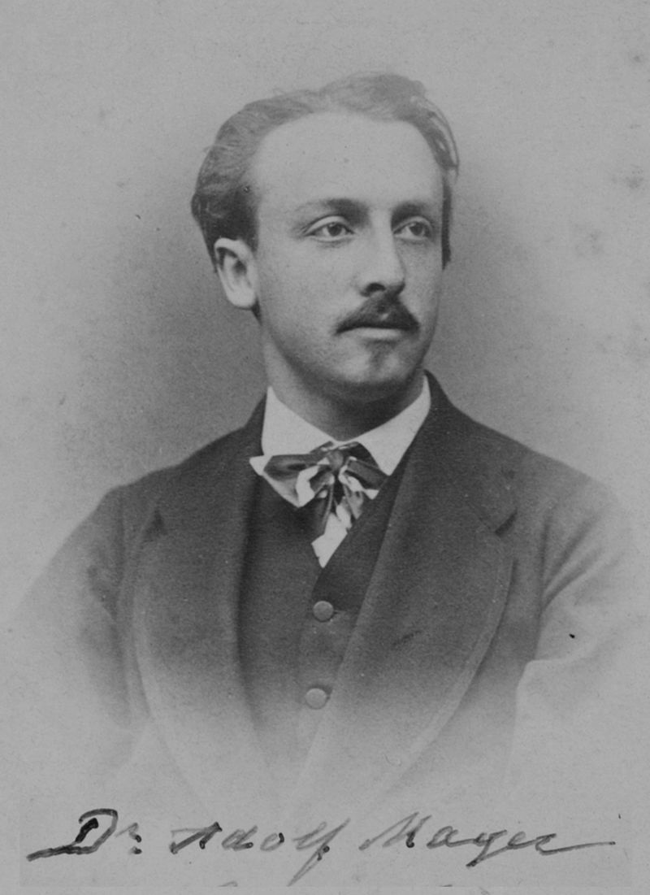

Figure 2: Adolf Mayer in 1875
Three hypotheses regarding their origin exist:
  - viruses arose from non – living matter.
  - viruses arose by genome reduction from earlier.
  - viruses arose from mobile genetic elements of cells that became encapsulated in protein capsids.
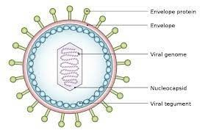
Figure 3: Structure of virus

Other uses of viruses:
- Anew application of genetically engineered viruses in nanotechnology was recently described ; see the uses of viruses in material science and nanotechnology. For use in mapping neurons see the application of pseudorabies in neuroscience .

Conclusion:
Im this research , we talked about the most important information related to virology with the most knowledge possible about viruses in terms of their definition, history, discovery and types , with a warning on the need to take the necessary measures to prevent them despite their benefits in some cases , and in the end I hope that the explanation is sufficiently clear and brief.

Index:
- Submicroxopic: too small to be seen in an ordinary light microxope.
- Geometrical : consisting of lines and simple shapes .
- NMR spectroxopy :Nuclear magnetic resonance.
- Viroids : are small infection pathogens.
- Nanotechnology : is a field of research and innovation concerned with building generally.

- Bibliography :
8-1- List of figures:
Figure 1: Gamma phage, an example of a virus
Figure 2: Adolf Mayer in 1875
Figure 3: Structure of virus
8-2 Sources:
- https://www.passionsante.be/index%20.cfm?fuseaction%20=%20art_%20id=%2019626
- www.wekipedia.com

