TD1
Initiation à JavaFX
Commençons par la construction d’une interface très simple : une simple contenant un bouton, dessinée ci-dessous :
Le code qui permet d’afficher cette interface est le suivant :
import javafx.application.Application;
import javafx.scene.Scene;
import javafx.scene.control.Button;
import javafx.stage.Stage;

public class MyJavaFX extends Application {
@Override // Override the start method in the Application class
public void start(Stage primaryStage) {
// Create a button and place it in the scene
Button btOK = new Button("OK");
Scene scene = new Scene(btOK, 200, 250);
primaryStage.setTitle("MyJavaFX"); // Set the stage title
primaryStage.setScene(scene); // Place the scene in the stage
primaryStage.show(); // Display the stage
}

/**
* The main method is only needed for the IDE with limited
* JavaFX support. Not needed for running from the command line.
*/
public static void main(String[] args) {
launch(args);
}
}
Ce programme permet d’afficher une seule scène. On peut afficher plusieurs scènes :
Exercice 2 : affichage de 2 scènes.
import javafx.application.Application;
import javafx.scene.Scene;
import javafx.scene.control.Button;
import javafx.stage.Stage;

public class MultipleStageDemo extends Application {

public void start(Stage primaryStage) {
// Create a scene and place a button in the scene
Scene scene = new Scene(new Button("OK"), 200, 250);
primaryStage.setTitle("MyJavaFX"); // Set the stage title
primaryStage.setScene(scene); // Place the scene in the stage
primaryStage.show(); // Display the stage

Stage stage = new Stage(); // Create a new stage
stage.setTitle("Second Stage"); // Set the stage title
// Set a scene with a button in the stage
stage.setScene(new Scene(new Button("New Stage"), 100, 100));
stage.show(); // Display the stage
}

/**
* The main method is only needed for the IDE with limited
* JavaFX support. Not needed for running from the command line.
*/
public static void main(String[] args) {
launch(args);
}
}
On obtient l’affichage suivant :
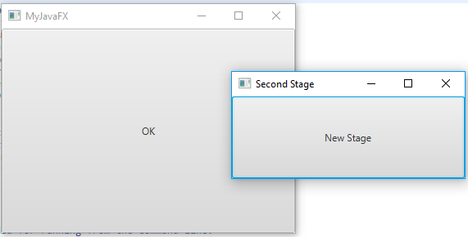
Il existe plusieurs types de pane (sous-classes de la classe Pane):
- StackPane : Les éléments sont « empilés » les uns sur les autres
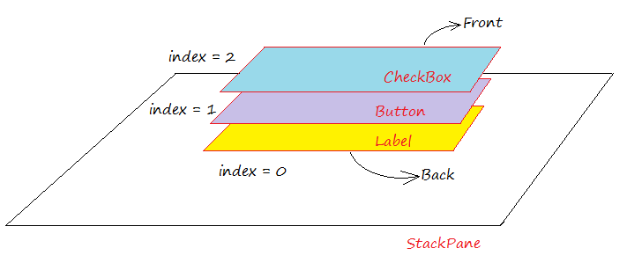
Exercice 3
import javafx.application.Application;
import javafx.scene.Scene;
import javafx.scene.control.Button;
import javafx.scene.layout.StackPane;
import javafx.stage.Stage;

public class ButtonInPane extends Application {

public void start(Stage primaryStage) {
// Create a scene and place a button in the scene
StackPane pane = new StackPane();
pane.getChildren().add(new Button("OK"));
Scene scene = new Scene(pane, 400, 100);
primaryStage.setTitle("Button in a pane"); // Set the stage title
primaryStage.setScene(scene); // Place the scene in the stage
primaryStage.show(); // Display the stage
}

public static void main(String[] args) {
launch(args);
}
}

- FlowPane : les éléments sont placés de gauche à droite et de haut en bas
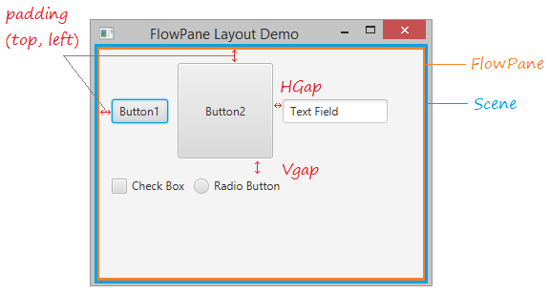

Exercice 4:
import javafx.application.Application;
import javafx.geometry.Insets;
import javafx.scene.Scene;
import javafx.scene.control.Label;
import javafx.scene.control.TextField;
import javafx.scene.layout.FlowPane;
import javafx.stage.Stage;

public class ShowFlowPane extends Application {

public void start(Stage primaryStage) {
// Create a pane and set its properties
FlowPane pane = new FlowPane();
pane.setPadding(new Insets(11, 12, 13, 14));
pane.setHgap(5);
pane.setVgap(5);

// Place nodes in the pane
pane.getChildren().addAll(new Label("First Name:"),
new TextField(), new Label("MI:"));
TextField tfMi = new TextField();
tfMi.setPrefColumnCount(1);
pane.getChildren().addAll(tfMi, new Label("Last Name:"),
new TextField());

// Create a scene and place it in the stage
Scene scene = new Scene(pane, 200, 250);
primaryStage.setTitle("ShowFlowPane"); // Set the stage title
primaryStage.setScene(scene); // Place the scene in the stage
primaryStage.show(); // Display the stage
}

public static void main(String[] args) {
launch(args);
}
}

- TilePane : les éléments sont alignés de gauche à droite et de haut en bas avec des espaces égaux.
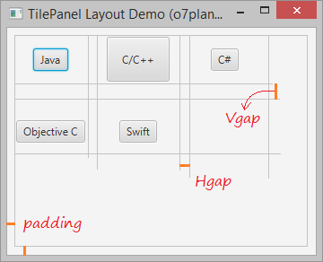
Exercice 5 :
import javafx.application.Application;
import javafx.geometry.Insets;
import javafx.scene.Scene;
import javafx.scene.control.Button;
import javafx.scene.layout.TilePane;
import javafx.stage.Stage;

public class TilePaneDemo extends Application {

@Override
public void start(Stage primaryStage) throws Exception {
TilePane root = new TilePane();

root.setPadding(new Insets(10,10,10,10));
root.setHgap(20);
root.setVgap(30);

Button button = new Button("Java");
root.getChildren().add(button);

// Short Button
Button button1 = new Button("C/C++");
button1.setPrefSize(70, 50);
root.getChildren().add(button1);

// Short Button
Button button2 = new Button("C#");

root.getChildren().add(button2);

// Button
Button longButton3 = new Button("Objective C");
root.getChildren().add(longButton3);

// Button
Button button4 = new Button("Swift");
root.getChildren().add(button4);

Scene scene = new Scene(root, 500, 300);
primaryStage.setTitle("TilePanel Layout Demo (o7planning.org)");
primaryStage.setScene(scene);
primaryStage.show();
}

public static void main(String[] args) {
launch(args);
}

}

- HBox et VBox :
  - HBox : Les éléments sont disposés dans un container horizontal de gauche à droite
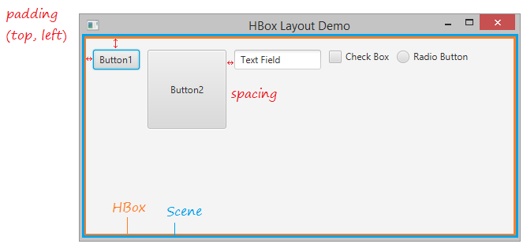
  - Vbox : Les éléments sont disposés dans un container vertical de haut en bas
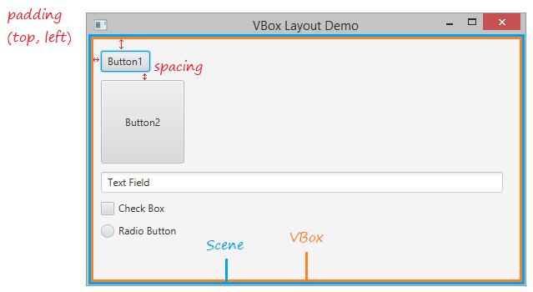
- BorderPane : Les éléments sont disposés selon 4 directions et un centre.
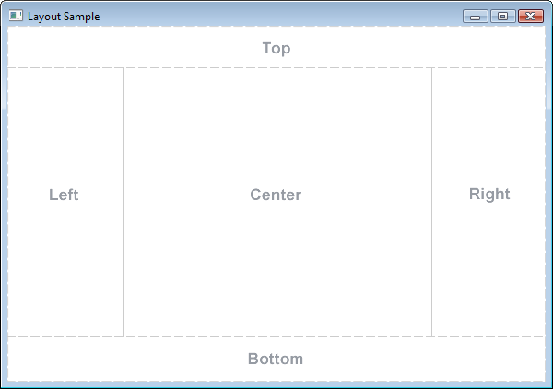
- GridPane : les éléments sont disposés selon une grille avec des indices (colonne, ligne).
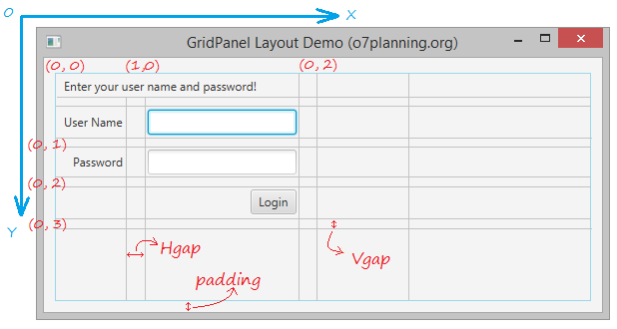

Remarque :
Tous les panes précédents peuvent être imbriqués les uns dans les autres pour créer des interfaces complexes et variées.
Exemple 6 utilisant un BorderPane avec HBox et VBox :
import javafx.application.Application;
import javafx.geometry.Insets;
import javafx.scene.Scene;
import javafx.scene.control.Button;
import javafx.scene.control.Label;
import javafx.scene.layout.BorderPane;
import javafx.scene.layout.HBox;
import javafx.scene.layout.VBox;
import javafx.stage.Stage;
import javafx.scene.image.Image;
import javafx.scene.image.ImageView;

public class ShowHBoxVBox extends Application {
@Override // Override the start method in the Application class
public void start(Stage primaryStage) {
// Create a border pane
BorderPane pane = new BorderPane();

// Place nodes in the pane
pane.setTop(getHBox());
pane.setLeft(getVBox());

// Create a scene and place it in the stage
Scene scene = new Scene(pane);
primaryStage.setTitle("ShowHBoxVBox"); // Set the stage title
primaryStage.setScene(scene); // Place the scene in the stage
primaryStage.show(); // Display the stage
}

private HBox getHBox() {
HBox hBox = new HBox(15);
hBox.setPadding(new Insets(15, 15, 15, 15));
hBox.setStyle("-fx-background-color: gold");
hBox.getChildren().add(new Button("Computer Science"));
hBox.getChildren().add(new Button("Chemistry"));
// ImageView imageView = new ImageView(new Image("image/us.gif"));
// hBox.getChildren().add(imageView);
return hBox;
}

private VBox getVBox() {
VBox vBox = new VBox(15);
vBox.setPadding(new Insets(15, 5, 5, 5));
vBox.getChildren().add(new Label("Courses"));

Label[] courses = {new Label("CSCI 1301"), new Label("CSCI 1302"),
new Label("CSCI 2410"), new Label("CSCI 3720")};

for (Label course: courses) {
VBox.setMargin(course, new Insets(0, 0, 0, 15));
vBox.getChildren().add(course);
}

return vBox;
}

/**
* The main method is only needed for the IDE with limited
* JavaFX support. Not needed for running from the command line.
*/
public static void main(String[] args) {
launch(args);
}
}

Exercice 7 avec un GridPane :
import javafx.application.Application;
import javafx.geometry.HPos;
import javafx.geometry.Insets;
import javafx.geometry.Pos;
import javafx.scene.Scene;
import javafx.scene.control.Button;
import javafx.scene.control.Label;
import javafx.scene.control.TextField;
import javafx.scene.layout.GridPane;
import javafx.stage.Stage;

public class ShowGridPane extends Application {
@Override // Override the start method in the Application class
public void start(Stage primaryStage) {
// Create a pane and set its properties
GridPane pane = new GridPane();
pane.setAlignment(Pos.CENTER); //affiche le pane en position centree H et V dans la scene
pane.setPadding(new Insets(11.5, 12.5, 13.5, 14.5));
pane.setHgap(5.5);
pane.setVgap(5.5);

// Place nodes in the pane
pane.add(new Label("First Name:"), 0, 0);
pane.add(new TextField(), 1, 0);
pane.add(new Label("MI:"), 0, 1);
pane.add(new TextField(), 1, 1);
pane.add(new Label("Last Name:"), 0, 2);
pane.add(new TextField(), 1, 2);
Button btAdd = new Button("Add Name");
pane.add(btAdd, 1, 3);
GridPane.setHalignment(btAdd, HPos.RIGHT);

// Create a scene and place it in the stage
Scene scene = new Scene(pane);
primaryStage.setTitle("ShowGridPane"); // Set the stage title
primaryStage.setScene(scene); // Place the scene in the stage
primaryStage.show(); // Display the stage
}

/**
* The main method is only needed for the IDE with limited
* JavaFX support. Not needed for running from the command line.
*/
public static void main(String[] args) {
launch(args);
}

Exercice 8: En utilisant les différents panes, écrire les programmes permettant d’obtenir les interfaces suivantes :
- 

 