**Sentence Stress in English**

The basic rules of [sentence stress](https://www.englishclub.com/pronunciation/sentence-stress.htm) are: (1) **content words** are **stressed,** (2) **structure words** are **unstressed** (3) the **time between stressed words** is always the **same**

The following tables can help you decide which words are **content words** and which words are **structure words**:

## **Content words - stressed**

| words carrying the meaning | example |
| --- | --- |
| main verbs | SELL, GIVE, EMPLOY |
| nouns | CAR, MUSIC, MARY |
| adjectives | RED, BIG, INTERESTING |
| adverbs | QUICKLY, WHY, NEVER |
| **negative** auxiliaries | DON'T, AREN'T, CAN'T |

## **Structure words - unstressed**

| words for correct grammar | example |
| --- | --- |
| pronouns | he, we, they |
| prepositions | on, at, into |
| articles | a, an, the |
| conjunctions | and, but, because |
| auxiliary verbs | do, be, have, can, must |

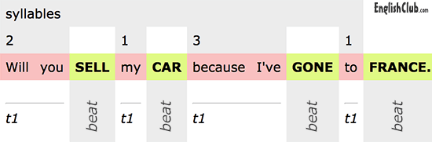

## **Exceptions**

The rules above are for for what is called "neutral" or normal stress. But sometimes we can stress a word that would normally be only a structure word, for example to correct information. Look at the following dialogue:

"They've been to Mongolia, haven't they?"

"No, **THEY** haven't, but **WE** have."

Note also that when "be" is used as a main verb, it is usually unstressed—even though as a main verb it is also a content word.

**Sentence Stress Quiz**

1. Which words in a sentence are usually stressed? ……….content words / ……….structure words

2. Which words carry little meaning but make a sentence grammatically correct?

……….content words / ……….structure words

3. When speaking English, we try to create a rhythm in which the time between stressed words is

……….the same / ……….different

4. Which is a list of content words? …….they, should've, through / …….Donald's, eyes, small

5. Which are NOT usually stressed?

……….prepositions, articles, pronouns, conjunctions / …….nouns, main verbs, adjectives, adverbs

6. Which is the normal neutral stress pattern?

……….If you CAN, CALL me in the MORNING. / ……….If you can, call ME in the MORNING.

7. Which is the normal neutral stress pattern?

.…THEY went TO London to VISIT the QUEEN. / .They WENT to LONDON to VISIT the QUEEN.

8. Which is the normal neutral stress pattern?

……If we COOK, could you WASH the DISHES? / ……If WE cook, could YOU wash the dishes?

9. An exception to the rule: We can also stress structure words in order to ……wrong information. ……….provide / ……….correct

10. Which stress pattern corrects this statement? "I'm sure they work for the police."

……….THEY don't, but WE do. / ……….They don't, BUT we do.

**Exercise**

Determine the meaning in each of the following depending on stress shift.

1. **Jack** will cycle to the restaurant tonight…………………………………………………………….

2. Jack **will** cycle to the restaurant tonight. ……………………………………………………………

3. Jack will **cycle** to the restaurant tonight. ……………………………………………………………

4. Jack will cycle **to** the restaurant tonight. ………………...…………………………………………

5. Jack will cycle to the **restaurant** tonight. ………………….………………………………………

6. Jack will cycle to the restaurant **tonight**. …………………...………………………………………