CURRICULUM VITAE
Family name: HOGGAS
First name: BACHIR
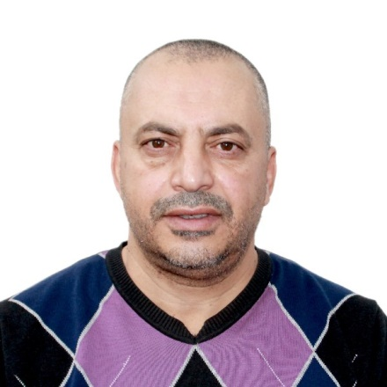
Date of birth: 07/03/1971
Place of birth: KHENCHELA
Nationality: Algerian
Address: rue de Amirra karare N 13; Tazoult W. Batna
Phone: +213793074986
Email: Hoggas41@gmail.com
Studies and Work:
Baccalaureate in technical mathematics. (1986/1989)--technical high school of Batna.
Diploma: Master’s degree, in aeronautics’. (1989/1996)—National Aviation University of Kyiv.
Doctoral degree in hydraulics and hydrology. (2005/2012) – National Technical University of Ukraine “ Igor Sikorski Kyiv Polytechnic Institute “.
University teacher in hydraulics’ department of university Batna-2. From 2014 to the present day.
subjects taught:
1-numerical method for programming;
2- Fluid mechanics;
3- Statistical hydrology;
4- Surface hydrology;
5- Free surface flow;
6- General hydraulics;
7- Hydraulic machine and pumping stations
Software: AutoCAD; MATLAB; ANSYS; COMSOL Metaphysics.
Languages:
French: very good
Arabic: very good
Russian: very good
English: Good
Publication:
- Vakoultchik A. V., Hoggas Bachir, Nogun N. V. features of an unstabilized flow of a non-Newtonian fluid. mechanical engineering bulletin, Kiev polytechnic- Ukraine, Tom 2, Page 216-222; 2000.

- Bagdanov O.C., Hoggas Bachir. comparison of rheological characteristics of Algerian and Ukrainian oils. mechanical engineering bulletin, Kharkov polytechnic – Ukrain, issue 129, 334 -341; 2001.

- Hoggas Bachir, Savtchenko N. V. features of viscous fluid flow in channels with varying flow rate along the length. Journal pramislova gidravlika I pnivmatika; 1(7); Page “31-35. Vinnytsia - Ukraine; 2005.

- Hoggas Bachir. Parkhomtchouk V. A. A mixture of the viscous liquids with changing their weight on their length. Journal pramislova gidravlika I pnivmatika; 4(14); Page 56-59. Vinnytsia - Ukraine; 2006.

- Hoggas Bachir. Parkhomtchouk V. A. Rheological studies of oil samples from Ukraine and Algeria. Journal des sciences of East Ukrainian N ational university Volodymyr Dahl; 3(109) part 2; Page 192-196 Luhansk – Ukraine; 2007.

- Hoggas bachir. The motion of viscous liquid in pipe line with various consumption of liquid through the length of it. Journal pramislova gidravlika I pnivmatika; 4(22); Page 43-46. Vinnytsia - Ukraine; 2008.

- Hoggas Bachir. physical modeling of the flow of abnormally viscous fluids in pipelines with length-varying flow rate. Eastern-European Journal of Enterprise technologies; 5/7(59); Page 33-38; 2012.

- Alona Murachenko, Aleksandr Gubarev, Oleg Yakhno, Bachir Hoggas. Approximate method of calculating the effect of temperature difference of the work the system hydro drive, International Scientific Conference “UNITECH 2015” – Gabrovo. Bulgarie.

- Hoggas Bachir . Hezil saddek. The influence of the choice of the parameter γ on the variation of the pressure and the flow rate, when the valve is closed at the end by the gravity feed of the pipe. Mechanics and advanced technologies. 2018; 82 (No. 1 (2018);Page 82-91.

- Member of international editorial staff of journal Mechanics and advanced technologies: National Technical University of Ukraine “ Igor Sikorski Kyiv Polytechnic Institute “ ; from 2017 to the present day.

