Lecture one: What is ICT (information and communications
technology, or technologies)?

1. Definition
ICT, or information and communications technology (or technologies), is the infrastructure and components that enable modern computing.
Although there is no single, universal definition of ICT, the term is generally accepted to mean all devices, networking components, applications and systems that combined allow people and organizations (i.e., businesses, nonprofit agencies, governments and criminal enterprises) to interact in the digital world.

2. Components of an ICT system
ICT encompasses both the internet-enabled sphere as well as the mobile one powered by wireless networks. It also includes antiquated technologies, such as landline telephones, radio and television broadcast -- all of which are still widely used today alongside cutting-edge ICT pieces such as artificial intelligence and robotics.
ICT is sometimes used synonymously with IT (for information technology); however, ICT is generally used to represent a broader, more comprehensive list of all components related to computer and digital technologies than IT.
The list of ICT components is exhaustive, and it continues to grow. Some components, such as computers and telephones, have existed for decades. Others, such as smartphones, digital TVs and robots, are more recent entries.
ICT commonly means more than its list of components, though. It also encompasses the application of all those various components. It's here that the real potential, power and danger of ICT can be found.
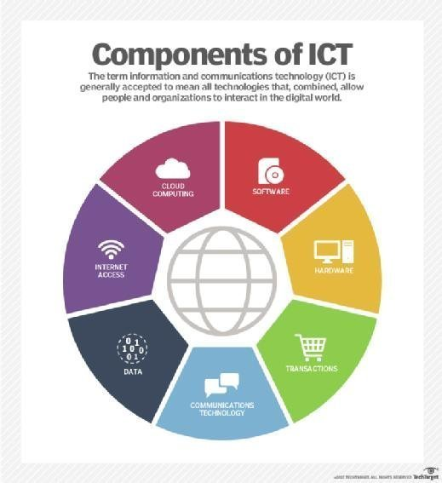

3. ICT's societal and economic impact
ICT is leveraged for economic, societal and interpersonal transactions and interactions. ICT has drastically changed how people work, communicate, learn and live. Moreover, ICT continues to revolutionize all parts of the human experience as first computers and now robots do many of the tasks once handled by humans. For example, computers once answered phones and directed calls to the appropriate individuals to respond; now robots not only can answer the calls, but they can often more quickly and efficiently handle callers' requests for services.
ICT's importance to economic development and business growth has been so monumental, in fact, that it's credited with ushering in what many have labeled the Fourth Industrial Revolution.
ICT also underpins broad shifts in society, as individuals en masse are moving from personal, face-to-face interactions to ones in the digital space. This new era is frequently termed the Digital Age.
For all its revolutionary aspects, though, ICT capabilities aren't evenly distributed. Simply put, richer countries and richer individuals enjoy more access and thus have a greater ability to seize on the advantages and opportunities powered by ICT.
Consider, for example, some findings from the World Bank. In 2016, it stated that more than 75% of people worldwide have access to a cellphone. However, internet access through either mobile or fixed Broadband remains prohibitively expensive in many countries due to a lack of ICT infrastructure. Furthermore, the World Bank estimated that out of the global population of 7.4 billion people, more than 4 billion don't have access to the internet. Additionally, it estimated that only 1.1 billion people have access to high-speed internet.
In the United States and elsewhere, this discrepancy in access to ICT has created the so-called digital divide.
The World Bank, numerous governmental authorities and non-government organizations (NGOs) advocate policies and programs that aim to bridge the digital divide by providing greater access to ICT among those individuals and populations struggling to afford it.
These various institutions assert that those without ICT capabilities are left out of the multiple opportunities and benefits that ICT creates and will therefore fall further behind in socio-economic terms.
The United Nations considers one of its Sustainable Development Goals (SDG) to "significantly increase access to information and communications technology and strive to provide universal and affordable access to the internet in least developed countries by 2020."
Economic advantages are found both within the ICT market as well as in the larger areas of business and society as a whole.
Within the ICT market, the advancement of ICT capabilities has made the development and delivery of various technologies cheaper for ICT vendors and their customers while also providing new market opportunities. For instance, telephone companies that once had to build and maintain miles of telephone lines have shifted to more advanced networking materials and can provide telephone, television and internet services; consumers now enjoy more choices in delivery and price points as a result.

4. The significance of ICT in enterprises
For businesses, advances within ICT have brought a slew of cost savings, opportunities and conveniences. They range from highly automated businesses processes that have cut costs, to the big data revolution where organizations are turning the vast trove of data generated by ICT into insights that drive new products and services, to ICT-enabled transactions such as internet shopping and telemedicine and social media that give customers more choices in how they shop, communicate and interact.
But ICT has also created problems and challenges to organizations and individuals alike -- as well as to society as a whole. The digitization of data, the expanding use of high-speed internet and the growing global network together have led to new levels of crime, where so-called bad actors can hatch electronically enabled schemes or illegally gain access to systems to steal money, intellectual property or private information or to disrupt systems that control critical infrastructure. ICT has also brought automation and robots that displace workers who are unable to transfer their skills to new positions. And ICT has allowed more and more people to limit their interactions with others, creating what some people fear is a population that could lose some of what makes it human.

